THE FINANCIAL AND ESTATE PLANNING COUNCIL OF METROPOLITAN DETROIT
Presents

Wednesday, October 30, 2024 Annual Dinner Meeting
Orchard Lake Country Club, 5000 W. Shore Dr., Orchard Lake, MI 48324
“The Greatness Standard: Be Bold”
Dr. Kevin Elko
Sport Psychologist, Performance and Career Consultant

5:00 pm to 5:45 pm – cocktails & appetizers - lobby and outside patio
5:45 pm to 6:45 pm – presentation - main dining room
6:45 pm to 7:45 pm– annual meeting during dinner

Pricing:
$75.00 FEPCMD Members / $55.00 FEPCMD Next Gen Members (age 35 and under)
$95.00 Guests / $75.00 / Next Gen Guests (age 35 and under)
Please register online or mail check by 10-18-24:
FEPCMD, 33006 W. Seven Mile Road, #237, Livonia, MI 48152

Name:______________________________ Name: ______________________________________
Key Presentation Points from Dr. Elko:

I have learned one thing about champions and high achievers and working as a performance consultant – they have high standards, and they never change them, water them down or bargain. The “Best of the Best” have defined who they are, set a high vision, have big bold goals, and finish everything they do. Winning to them is not a sometime thing – it’s a standard – so it is an all the time thing. And that is clear to themselves and everyone around them. The Standard is not something that changes and is not negotiable. The Standard is clearly defined, and one reminds themselves of The Standard on a regular basis. When they reinforce this concept over and over to themselves, they become “wired” with The Winners Circle. The challenge is keeping The Standard in all aspects of your life. This presentation will help you widen the plate.

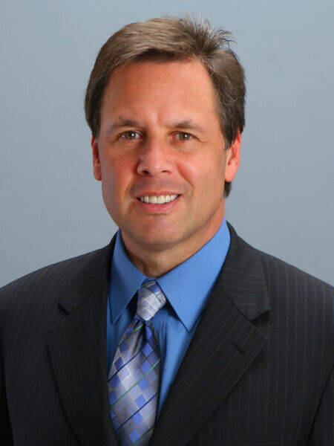
DR. KEVIN ELKO received his Bachelors in Biology Education and Coaching from California University of Pennsylvania. He then went on to West Virginia University where he received two Masters and a Doctorate and was later inducted into West Virginia University Hall of Fame. He has consulted with various successful NFL teams including The Pittsburgh Steelers, The Dallas Cowboys, The Philadelphia Eagles, The Miami Dolphins and The New Orleans Saints. In college sports, Dr. Elko has worked with several BCS National Championship Football Teams including The University of Miami, L.S.U., The University of Alabama, and Florida State University. In the business world, Dr. Elko focuses on helping organizations in the areas of Leadership, Goal Setting, and various other motivational topics. His corporate clients have included New York Life Investments, ING, Tyson Foods, Abbott Labs, LPL Financial, The Hartford, Genworth, Jackson National Life, Pioneer Investments, Morgan Stanley, Bank of America, Merrill Lynch, and Sun Life just to mention a few. Dr. Elko is the author of seven books, Nerves of Steel, The Pep Talk, True Greatness: Mastering the Inner Game of Business Success, Touchdown: Achieving Your Greatness on the Playing Field of Business and Life, the Sender, Sender Companion Journal and Believing is Seeing.
Thank You To Our 2024 Sponsors
Bank of Ann Arbor Gordon Advisors Plunkett Cooney
BDO Greenleaf Trust PLUS Financial Network
Berry Moorman Huntington Private Bank Principal Financial
Blue Chip Partners, LLC Jackson National Pugh Moak P.C.
Butzel Long JP Morgan Private Bank Rehmann
CIBC Private Wealth Management Kercheval Financial Group of Wells Fargo Advisors
Couzens Lansky Lifetime Financial Growth of Michigan
Dawda Mann LoVasco Consulting Group Schluter & Hughes Law Firm, PLLC
Doeren Mayhew Maddin Hauser Stonebridge Financial Partners, LLC
Dykema MRPR CPAs & Advisors Stout
Giarmarco, Mullins & Horton, PC Northwestern Mutual Varnum
Giroux Pappas Trial Attorneys Plante Moran Wealth Management Wipfl

