Sam Donaldson’s Favorite Cocktail
Aviation

Cocktail Tutorial Preceding the 11-18-20 Webinar

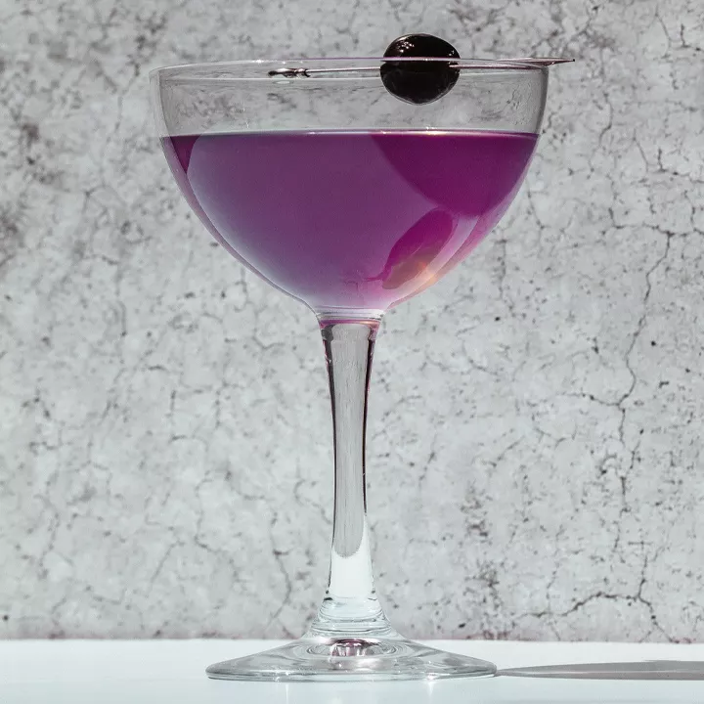

List of Ingredients

2 ounces gin
2/3 ounce maraschino liqueur
2/3 ounce crème de violette
3/4 ounce fresh lemon juice (about ½ of a large lemon)
Garnish: brandied cherry
Optional: ½ ounce triple sec

