THE FINANCIAL AND ESTATE PLANNING COUNCIL OF METROPOLITAN DETROIT
Presents

Wednesday, September 15, 2021
AGENDA:

11:00 am presentation – 11:50 am Q&A

COMPLIMENTARY WEBINAR
REGISTER HERE

Ric Edelman
“Understanding Blockchain and Digital Assets”

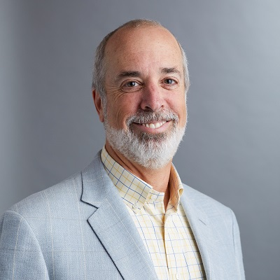

PRESENTATION OUTCOMES:

Is Bitcoin a fad or a revolution that will transform commerce on a planetary scale? This complimentary webinar will provide you with needed and timely information regarding this new technology so you can decide whether – and how – to engage with clients. This vital session will remove the mystery about blockchain and digital assets – helping you learn the implications for advisors, clients and firms.

Ric Edelman, legendary financial advisor, 3 times ranked the #1 Independent Financial Advisor in the nation by Barron’s and founder of the largest independent RIA firm in the country. TALKERS magazine named Ric one of the top 100 radio talk show hosts in the country, and he has produced award-winning specials for PBS. He’s also the #1 New York Times bestselling author of 10 books on personal finance.

The FEPCMD is pleased to present this webinar in partnership with the Advanced Planning Educational Group, Inc., Producers Choice and RightCapital.

Thank You To Our 2021Sponsors

BDO Jaffe Berry Moorman Kercheval Financial Group of Wells Fargo
Butzel Long Lifetime Financial Growth of Michigan
Clayton & McKervey, PC Maddin Hauser
Comerica Merrill Lynch Community Foundation for SE Michigan Miller Canfield
Couzens Lansky Northern Trust
Dawda Mann Northwestern Mutual
Dickinson Wright, PLLC Plante Moran Wealth Management
Dykema Plunkett Cooney
Giarmarco, Mullins & Horton, PC Rehmann
Gordon Advisors Rochester University
Greenleaf Trust Schechter Wealth
Hindman Auctioneers Varnum
Huntington Private Bank Warner
Jackson National Wells Fargo Private Bank
Williams Williams Ratner & Plunkett, P.C.

